MintClassic Database Case Study Conclusions and Recommendations

As part of the Coursera project, I share my results as part of a portfolio to show my acquired knowledge in databases and Tableu public for the aspiration of being a Jr. Data Analyst. The following project was done in approximately 10 hours taking as main source of data the database shared by the Coursera platform.

This project was done using as database manager Oracle's MySQL Worbench in its version 8.0.0 Comunity Edition, also Tableu Public in its version 7.0 Desktop was used. Both free softwares were used to demonstrate familiarity with these programs. Several tests were also carried out using XAMMP, the graphical part directly from Excel, but for better results in this specific case it was decided to use the aforementioned technologies.

Tableu Link

<https://public.tableau.com/views/Proyecto_16896993966620/Dashboard1?:language=es-ES&publish=yes&:display_count=n&:origin=viz_share_link>

Context of the case study.

The following case study, was conducted in order for a store whose main product is the sale of scale vehicles, to make a decision on whether or not to close one of its stores and thus seek to take action based on the advice given.

The first thing to note is as can be seen in the following chart.

The 4 warehouses with names East, West, North and South have a distribution as follows.

|  |  |
| --- | --- |
| East | 39,48 |
| North | 23,72 |
| West | 22,5 |
| South | 14,3 |

The **East warehouse has the largest quantity with 39.48%** of the total distribution among all warehouses. It should also be noted that each of the product categories is stored in a specific warehouse as shown in the following table

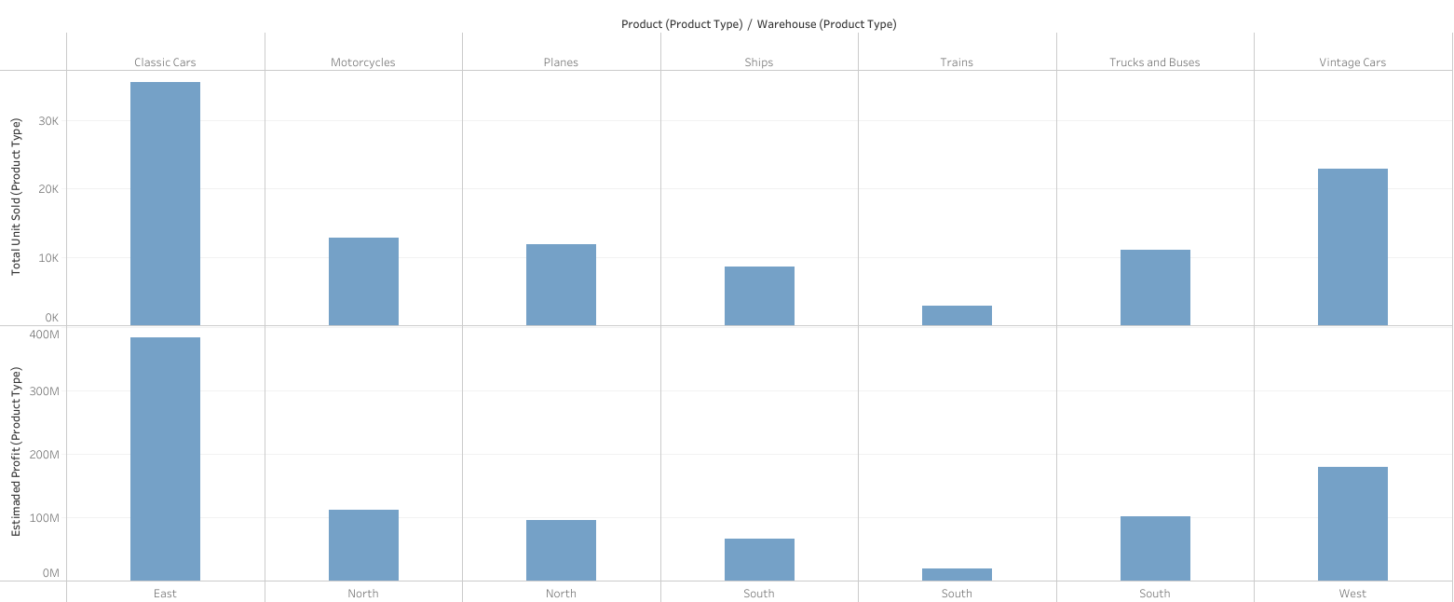

Each category is stored in a single warehouse.

|  |  |  |  |  |  |  |
| --- | --- | --- | --- | --- | --- | --- |
| **Product** | **Total_Oders** | **Total_Unit_Sold** | **Estimaded_Profit** | **totalStock** | **porcentaje** | **Warehouse** |
| Classic Cars | 1010 | 35582 | 384301524 | 5844033 | 33,72 | East |
| Vintage Cars | 657 | 22933 | 179694017 | 3439570 | 21,73 | West |
| Motorcycles | 359 | 12778 | 111581233 | 1915517 | 12,11 | North |
| Planes | 336 | 11872 | 95364455 | 1744036 | 11,25 | North |
| Trucks and Buses | 308 | 11001 | 101989449 | 1003828 | 10,43 | South |
| Ships | 245 | 8532 | 66338041 | 732251 | 8,09 | South |
| Trains | 81 | 2818 | 18920191 | 450792 | 2,67 | South |

Which is particularly striking where despite the fact that **the ''South'' warehouse has only 14.3%** of the total stock of the 4 warehouses, it **has numbers similar to the percentage of units sold** as are the North and West warehouses, **with a total percentage with 21.19%.**

Now touching the subject of the ratio of units sold together with the total units kept in stock we obtain interesting information to analyze, as shown in the following table.

|  |  |  |  |  |  |
| --- | --- | --- | --- | --- | --- |
| **Product** | **Product_Type** | **Total_Unit_Sold** | **porcentaje** | **Total_Stock** | **Total_Stock_Less35P** |
| 2002 Suzuki XREO | Motorcycles | 1028 | 0,97 | 9997 | 6498 |
| 1995 Honda Civic | Classic Cars | 917 | 0,87 | 9772 | 6352 |
| America West Airlines B757-200 | Planes | 984 | 0,93 | 9653 | 6274 |
| 2002 Chevy Corvette | Classic Cars | 894 | 0,85 | 9446 | 6140 |

These are the list of products that have more stock in the warehouses, as can be detonated with **the 2002 Suzuki XRO model only represents 0.97%** **of total sales** which is a great average percentage, but **has 9997 units stored against 1028 sold**, which makes this model in the most stored, but not the most sold **if the stock is reduced by approximately 35%** and even more in certain products **would result in a total storage of 6498 products**, which despite being a considerable reduction does not seem to be optimal for other products.

Conclusions.

Before answering the questions that gave rise to this analysis, the following scenarios should be assumed.

1) All warehouses have the same storage capacity.

2) The products do not require different types of storage.

3) The warehouses have not yet reached their maximum capacity.

Right off the bat, Yes. The elimination of a warehouse if the above conditions are met would be ideal. The distribution would end up eliminating the South warehouse and distributing the total storage between the North and West warehouses to match the East warehouse.

Now, assuming that the East, North and West warehouses are close to their maximum capacities, a reduction of available stock would be excellent, if the elimination of one warehouse is desired.

Generally speaking, YES. It is plausible the elimination of a warehouse, the South warehouse would be the ideal candidate, since having fewer items logistically would be easier distribution, but it is advisable to make a warehouse review to achieve the optimal stock.